# Movies API Exercise

## December 2017 – Drama (18) had the highest voting participation and the most movie releases

We should begin with the most obvious view. Based simply on the API’s popularity scoring, War is the most popular movie genre for December 2017. However, the second graph will show that Drama received the most interactions (or votes) during December 2017. This may imply that more people formed opinions for Drama movies, and I would argue that “all press is good press.”

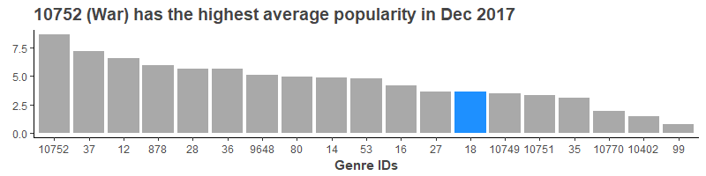

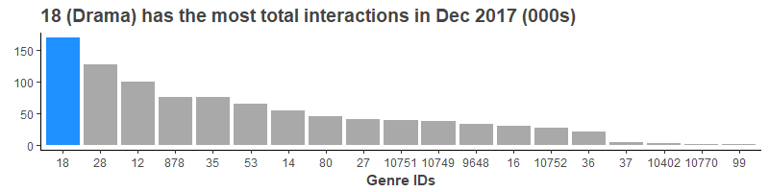

Additionally, it may be worthwhile to investigate profit to studios from these genres to see how much people “voted with their dollars.” As a very simple proxy, we can use the number of movie releases to anticipate movie makers’ collective profit-driven decisions. Here, Drama also rises to the top with significantly more releases than any other genres.

**It’s worth mentioning that the War (10752) movies that were voted on in December 2018 were wildly popular – they received the highest overall popularity score while have the second fewest movies available.**

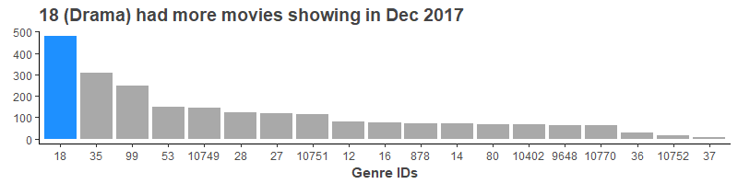

I spent a little time looking for a measure I could engineer from these others I’ve mentioned; however, none of the indexes or ratios I tried out proved very impactful.

## Beyond December 2017 – There’s no obvious pattern of popularity change over time

Overall for 2017 and 2018, Adventure (12) stands out as a leader in the API’s popularity scoring. This suggests that the December 2017 hype around the War genre was not sustained throughout the year. However, Drama remains on top for both years in Total Interactions and in Total Movies Available at the year total and quarterly levels.

The only other genre that gets close to taking Drama’s top spot is Action (28). On occasion, Action even surpasses Drama’s quarterly Total Interactions (see Q3 2017).

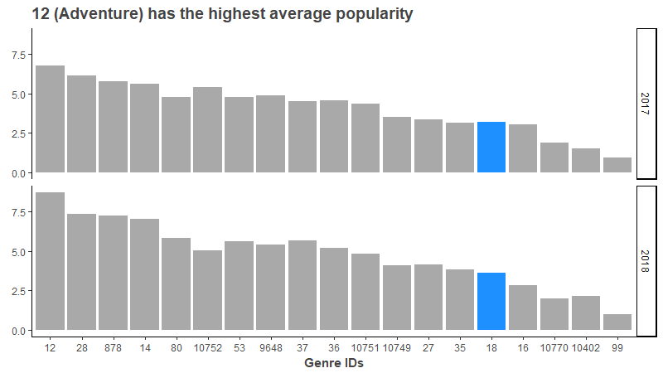

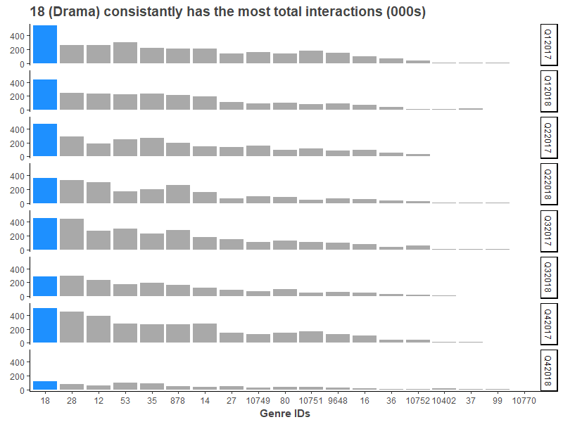

There doesn’t appear to be any obvious relationship between Genre Popularity (as I’ve defined it) and Time of Year. I looked at several factors including:

1. How each genre’s popularity and interactions measured against their overall averages each quarter / year
2. Where the largest increases occurred and whether or not they occurred in both years

In order to be sure, there are a couple things I’d want to look into:

1. What are the genres’ Profits and Gross Incomes over time?
2. How was the Popularity measure calculated?
3. How could I reduce some of the noise in the dataset by categorizing the genres?
4. What other features are available in the API that were overlooked?